OpenFDA_Prototype

Image16.png

dlam

Table of Contents

Stereotypes

Class Diagram

OpenFDA

com.wasoftware.openfda

Entity Relationship Diagram1

Drugs Adverse Events

Login

Master

Table of Figures

Class Diagram

OpenFDA

com.wasoftware.openfda

Entity Relationship Diagram1

Drugs Adverse Events

Login

Master

# Stereotypes

|  |  |
| --- | --- |
| UseCase | |
| Tagged Value Definitions | |  |  | | --- | --- | | Level | | | Type | Enumeration | | Enumeration Values | Summary, User, Subfunction | | Project Management | |  |  | | --- | --- | | Name | Value | | Author | dlam | | Create Date Time | Jul 7, 2014 2:07:06 PM | | Last Modified | Jun 24, 2015 3:32:45 PM | |  |  |  | | --- | --- | | Complexity | | | Type | Enumeration | | Enumeration Values | Low, Medium, High | | Project Management | |  |  | | --- | --- | | Name | Value | | Author | dlam | | Create Date Time | Jul 7, 2014 2:07:06 PM | | Last Modified | Jun 24, 2015 3:32:45 PM | |  |  |  | | --- | --- | | Use Case Status | | | Type | Enumeration | | Enumeration Values | Name Only, Initial, Base, Complete, Deferred | | Project Management | |  |  | | --- | --- | | Name | Value | | Author | dlam | | Create Date Time | Jul 7, 2014 2:07:06 PM | | Last Modified | Jun 24, 2015 3:32:45 PM | |  |  |  | | --- | --- | | Implementation Status | | | Type | Enumeration | | Enumeration Values | Scheduled, Started, Partially Complete, Complete, Partially Deferred | | Project Management | |  |  | | --- | --- | | Name | Value | | Author | dlam | | Create Date Time | Jul 7, 2014 2:07:06 PM | | Last Modified | Jun 24, 2015 3:32:45 PM | |  |  |  | | --- | --- | | Preconditions | | | Type | Multi-line Text | | Project Management | |  |  | | --- | --- | | Name | Value | | Author | dlam | | Create Date Time | Jul 7, 2014 2:07:06 PM | | Last Modified | Jun 24, 2015 3:32:45 PM | |  |  |  | | --- | --- | | Post-conditions | | | Type | Multi-line Text | | Project Management | |  |  | | --- | --- | | Name | Value | | Author | dlam | | Create Date Time | Jul 7, 2014 2:07:06 PM | | Last Modified | Jun 24, 2015 3:32:45 PM | |  |  |  | | --- | --- | | Author | | | Type | Text | | Project Management | |  |  | | --- | --- | | Name | Value | | Author | dlam | | Create Date Time | Jul 7, 2014 2:07:06 PM | | Last Modified | Jun 24, 2015 3:32:45 PM | |  |  |  | | --- | --- | | Assumptions | | | Type | Multi-line Text | | Project Management | |  |  | | --- | --- | | Name | Value | | Author | dlam | | Create Date Time | Jul 7, 2014 2:07:06 PM | | Last Modified | Jun 24, 2015 3:32:45 PM | | |

|  |  |
| --- | --- |
| requirement | |
| Tagged Value Definitions | |  |  | | --- | --- | | Text | | | Type | HTML | | Project Management | |  |  | | --- | --- | | Name | Value | | Author | dlam | | Create Date Time | Jul 7, 2014 2:07:05 PM | | Last Modified | Jun 24, 2015 3:32:45 PM | |  |  |  | | --- | --- | | ID | | | Type | Text | | Project Management | |  |  | | --- | --- | | Name | Value | | Author | dlam | | Create Date Time | Jul 7, 2014 2:07:05 PM | | Last Modified | Jun 24, 2015 3:32:45 PM | |  |  |  | | --- | --- | | source | | | Type | Text | | Project Management | |  |  | | --- | --- | | Name | Value | | Author | dlam | | Create Date Time | Jul 7, 2014 2:07:05 PM | | Last Modified | Jun 24, 2015 3:32:45 PM | |  |  |  | | --- | --- | | kind | | | Type | Enumeration | | Enumeration Values | Functional, Performance, Interface | | Project Management | |  |  | | --- | --- | | Name | Value | | Author | dlam | | Create Date Time | Jul 7, 2014 2:07:05 PM | | Last Modified | Jun 24, 2015 3:32:45 PM | |  |  |  | | --- | --- | | verifyMethod | | | Type | Enumeration | | Enumeration Values | Analysis, Demonstration, Inspection, Test | | Project Management | |  |  | | --- | --- | | Name | Value | | Author | dlam | | Create Date Time | Jul 7, 2014 2:07:05 PM | | Last Modified | Jun 24, 2015 3:32:45 PM | |  |  |  | | --- | --- | | risk | | | Type | Enumeration | | Enumeration Values | High, Medium, Low | | Project Management | |  |  | | --- | --- | | Name | Value | | Author | dlam | | Create Date Time | Jul 7, 2014 2:07:05 PM | | Last Modified | Jun 24, 2015 3:32:45 PM | |  |  |  | | --- | --- | | status | | | Type | Enumeration | | Enumeration Values | Proposed, Approved, Rejected, Deferred, Implemented, Mandatory, Obsolete | | Project Management | |  |  | | --- | --- | | Name | Value | | Author | dlam | | Create Date Time | Jul 7, 2014 2:07:05 PM | | Last Modified | Jun 24, 2015 3:32:45 PM | | |

|  |
| --- |
| ORM Persistable |

|  |
| --- |
| device |

|  |
| --- |
| load balancer |

Class Diagram

# Class Diagram

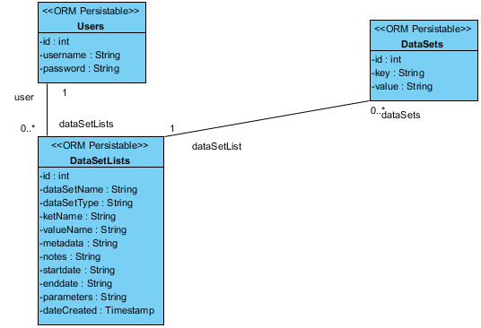

|  |  |
| --- | --- |
| Name | Value |
| Name | Class Diagram |
| Author | dlam |
| Create Date Time | Jun 24, 2015 3:36:57 PM |
| Last Modified | Jul 6, 2015 10:20:13 AM |
| Transit From | Image1.png Entity Relationship Diagram1 |
| Shape Presentation Option | 0 |

## Summary

|  |  |
| --- | --- |
| Name | Documentation |
| Image2.png Users |  |
| Image2.png DataSets |  |
| Image2.png DataSetLists |  |

## Details

### Image2.png Users

|  |  |
| --- | --- |
| Name | Value |
| Active | false |
| Business Key Mutable | true |
| Orm Detail | N/A |
| Business Model | false |
| Visibility | public |
| Leaf | false |
| Root | false |
| Stereotypes | ORM Persistable |
| Quality Score | Fair |
| Quality Reason | |  |  | | --- | --- | | Problem | Suggestion | | Model element at root | Add model element to a container | | Name does not contain glossary terms | Define name as term in glossary | |
| Project Management | |  |  | | --- | --- | | Name | Value | | Author | dlam | | Create Date Time | Jun 24, 2015 3:37:00 PM | | Last Modified | Jun 24, 2015 3:54:22 PM | |

#### Attributes

|  |  |  |  |
| --- | --- | --- | --- |
| private id : int | | | |
| Type | Image3.png int | | |
| Allow Empty Name | false | | |
| Getter | false | Setter | false |
| Derived | false | | |
| Multiplicity | 1 | | |
| Mapped Column | id | | |
| Aggregation | None | | |
| Derived Union | false | | |
| Read Only | false | | |
| Is ID | false | | |
| Leaf | false | | |
| Project Management | |  |  | | --- | --- | | Name | Value | | Author | dlam | | Create Date Time | Jun 24, 2015 3:37:00 PM | | Last Modified | Jun 24, 2015 3:37:06 PM | | | |

|  |  |  |  |
| --- | --- | --- | --- |
| private username : String | | | |
| Type | String | | |
| Allow Empty Name | false | | |
| Getter | false | Setter | false |
| Derived | false | | |
| Multiplicity | 0..1 | | |
| Mapped Column | username | | |
| Aggregation | None | | |
| Derived Union | false | | |
| Read Only | false | | |
| Is ID | false | | |
| Leaf | false | | |
| Project Management | |  |  | | --- | --- | | Name | Value | | Author | dlam | | Create Date Time | Jun 24, 2015 3:37:00 PM | | Last Modified | Jun 24, 2015 3:37:06 PM | | | |

|  |  |  |  |
| --- | --- | --- | --- |
| private password : String | | | |
| Type | String | | |
| Allow Empty Name | false | | |
| Getter | false | Setter | false |
| Derived | false | | |
| Multiplicity | 0..1 | | |
| Mapped Column | password | | |
| Aggregation | None | | |
| Derived Union | false | | |
| Read Only | false | | |
| Is ID | false | | |
| Leaf | false | | |
| Project Management | |  |  | | --- | --- | | Name | Value | | Author | dlam | | Create Date Time | Jun 24, 2015 3:37:00 PM | | Last Modified | Jun 24, 2015 3:37:06 PM | | | |

#### Relationships

|  |  |
| --- | --- |
| Unnamed Association | |
| To (dataSetLists) | |  |  | | --- | --- | | Name | Value | | End Model Element | Image2.png DataSetLists | | Provide Property Getter Method | false | | Provide Property Setter Method | false | | Orm Detail | N/A | | Multiplicity | 0..* | | Visibility | Unspecified | | Aggregation Kind | None | | Navigable | Navigable | | Derived | false | | Derived Union | false | | Read Only | false | | Static | false | | Leaf | false | | Project Management | |  |  | | --- | --- | | Name | Value | | Author | dlam | | Create Date Time | Jun 24, 2015 3:37:00 PM | | |
| Abstract | false |
| Leaf | false |
| Visibility | Unspecified |
| Quality Score | Good |
| Derived | false |
| Orm Detail | N/A |
| Project Management | |  |  | | --- | --- | | Name | Value | | Author | dlam | | Create Date Time | Jun 24, 2015 3:37:00 PM | | Last Modified | Jul 6, 2015 10:17:38 AM | |

#### ORM Class Detail

|  |  |
| --- | --- |
| Name | Value |
| Mapped Table | Image4.png Users |
| Read Only | false |
| Lazy | false |
| Cache | Disable |
| Inheritance Strategy | Table per class hierarchy |
| Reference | false |

### Image2.png DataSets

|  |  |
| --- | --- |
| Name | Value |
| Active | false |
| Business Key Mutable | true |
| Orm Detail | N/A |
| Business Model | false |
| Visibility | public |
| Leaf | false |
| Root | false |
| Stereotypes | ORM Persistable |
| Quality Score | Fair |
| Quality Reason | |  |  | | --- | --- | | Problem | Suggestion | | Model element at root | Add model element to a container | | Name does not contain glossary terms | Define name as term in glossary | |
| Project Management | |  |  | | --- | --- | | Name | Value | | Author | dlam | | Create Date Time | Jun 24, 2015 3:37:00 PM | | Last Modified | Jun 24, 2015 3:54:22 PM | |

#### Attributes

|  |  |  |  |
| --- | --- | --- | --- |
| private id : int | | | |
| Type | Image3.png int | | |
| Allow Empty Name | false | | |
| Getter | false | Setter | false |
| Derived | false | | |
| Multiplicity | 1 | | |
| Mapped Column | id | | |
| Aggregation | None | | |
| Derived Union | false | | |
| Read Only | false | | |
| Is ID | false | | |
| Leaf | false | | |
| Project Management | |  |  | | --- | --- | | Name | Value | | Author | dlam | | Create Date Time | Jun 24, 2015 3:37:00 PM | | Last Modified | Jun 24, 2015 3:37:06 PM | | | |

|  |  |  |  |
| --- | --- | --- | --- |
| private key : String | | | |
| Type | String | | |
| Allow Empty Name | false | | |
| Getter | false | Setter | false |
| Derived | false | | |
| Multiplicity | 0..1 | | |
| Mapped Column | key | | |
| Aggregation | None | | |
| Derived Union | false | | |
| Read Only | false | | |
| Is ID | false | | |
| Leaf | false | | |
| Project Management | |  |  | | --- | --- | | Name | Value | | Author | dlam | | Create Date Time | Jun 24, 2015 3:37:00 PM | | Last Modified | Jun 24, 2015 3:37:06 PM | | | |

|  |  |  |  |
| --- | --- | --- | --- |
| private value : String | | | |
| Type | String | | |
| Allow Empty Name | false | | |
| Getter | false | Setter | false |
| Derived | false | | |
| Multiplicity | 0..1 | | |
| Mapped Column | value | | |
| Aggregation | None | | |
| Derived Union | false | | |
| Read Only | false | | |
| Is ID | false | | |
| Leaf | false | | |
| Project Management | |  |  | | --- | --- | | Name | Value | | Author | dlam | | Create Date Time | Jun 24, 2015 3:37:00 PM | | Last Modified | Jun 24, 2015 3:37:06 PM | | | |

#### Relationships

|  |  |
| --- | --- |
| Unnamed Association | |
| From (dataSetList) | |  |  | | --- | --- | | Name | Value | | End Model Element | Image2.png DataSetLists | | Provide Property Getter Method | false | | Provide Property Setter Method | false | | Orm Detail | N/A | | Multiplicity | 1 | | Visibility | Unspecified | | Aggregation Kind | None | | Navigable | Navigable | | Derived | false | | Derived Union | false | | Read Only | false | | Static | false | | Leaf | false | | Project Management | |  |  | | --- | --- | | Name | Value | | Author | dlam | | Create Date Time | Jun 24, 2015 3:37:00 PM | | |
| Abstract | false |
| Leaf | false |
| Visibility | Unspecified |
| Quality Score | Good |
| Derived | false |
| Orm Detail | N/A |
| Project Management | |  |  | | --- | --- | | Name | Value | | Author | dlam | | Create Date Time | Jun 24, 2015 3:37:00 PM | | Last Modified | Jul 6, 2015 10:17:38 AM | |

#### ORM Class Detail

|  |  |
| --- | --- |
| Name | Value |
| Mapped Table | Image4.png DataSets |
| Read Only | false |
| Lazy | false |
| Cache | Disable |
| Inheritance Strategy | Table per class hierarchy |
| Reference | false |

### Image2.png DataSetLists

|  |  |
| --- | --- |
| Name | Value |
| Active | false |
| Business Key Mutable | true |
| Orm Detail | N/A |
| Business Model | false |
| Visibility | public |
| Leaf | false |
| Root | false |
| Stereotypes | ORM Persistable |
| Quality Score | Fair |
| Quality Reason | |  |  | | --- | --- | | Problem | Suggestion | | Model element at root | Add model element to a container | | Name does not contain glossary terms | Define name as term in glossary | |
| Project Management | |  |  | | --- | --- | | Name | Value | | Author | dlam | | Create Date Time | Jun 24, 2015 3:37:00 PM | | Last Modified | Jul 6, 2015 10:17:38 AM | |

#### Attributes

|  |  |  |  |
| --- | --- | --- | --- |
| private id : int | | | |
| Type | Image3.png int | | |
| Allow Empty Name | false | | |
| Getter | false | Setter | false |
| Derived | false | | |
| Multiplicity | 1 | | |
| Mapped Column | id | | |
| Aggregation | None | | |
| Derived Union | false | | |
| Read Only | false | | |
| Is ID | false | | |
| Leaf | false | | |
| Project Management | |  |  | | --- | --- | | Name | Value | | Author | dlam | | Create Date Time | Jun 24, 2015 3:37:00 PM | | Last Modified | Jun 24, 2015 3:37:06 PM | | | |

|  |  |  |  |
| --- | --- | --- | --- |
| private dataSetName : String | | | |
| Type | String | | |
| Allow Empty Name | false | | |
| Getter | false | Setter | false |
| Derived | false | | |
| Multiplicity | 0..1 | | |
| Mapped Column | dataSetName | | |
| Aggregation | None | | |
| Derived Union | false | | |
| Read Only | false | | |
| Is ID | false | | |
| Leaf | false | | |
| Project Management | |  |  | | --- | --- | | Name | Value | | Author | dlam | | Create Date Time | Jun 24, 2015 3:37:00 PM | | Last Modified | Jun 24, 2015 3:37:06 PM | | | |

|  |  |  |  |
| --- | --- | --- | --- |
| private dataSetType : String | | | |
| Type | String | | |
| Allow Empty Name | false | | |
| Getter | false | Setter | false |
| Derived | false | | |
| Multiplicity | 0..1 | | |
| Mapped Column | dataSetType | | |
| Aggregation | None | | |
| Derived Union | false | | |
| Read Only | false | | |
| Is ID | false | | |
| Leaf | false | | |
| Project Management | |  |  | | --- | --- | | Name | Value | | Author | dlam | | Create Date Time | Jun 24, 2015 3:37:00 PM | | Last Modified | Jun 24, 2015 3:37:06 PM | | | |

|  |  |  |  |
| --- | --- | --- | --- |
| private ketName : String | | | |
| Type | String | | |
| Allow Empty Name | false | | |
| Getter | false | Setter | false |
| Derived | false | | |
| Multiplicity | 0..1 | | |
| Mapped Column | ketName | | |
| Aggregation | None | | |
| Derived Union | false | | |
| Read Only | false | | |
| Is ID | false | | |
| Leaf | false | | |
| Project Management | |  |  | | --- | --- | | Name | Value | | Author | dlam | | Create Date Time | Jun 24, 2015 3:37:00 PM | | Last Modified | Jun 24, 2015 3:37:06 PM | | | |

|  |  |  |  |
| --- | --- | --- | --- |
| private valueName : String | | | |
| Type | String | | |
| Allow Empty Name | false | | |
| Getter | false | Setter | false |
| Derived | false | | |
| Multiplicity | 0..1 | | |
| Mapped Column | valueName | | |
| Aggregation | None | | |
| Derived Union | false | | |
| Read Only | false | | |
| Is ID | false | | |
| Leaf | false | | |
| Project Management | |  |  | | --- | --- | | Name | Value | | Author | dlam | | Create Date Time | Jun 24, 2015 3:37:00 PM | | Last Modified | Jun 24, 2015 3:37:06 PM | | | |

|  |  |  |  |
| --- | --- | --- | --- |
| private metadata : String | | | |
| Type | String | | |
| Allow Empty Name | false | | |
| Getter | false | Setter | false |
| Derived | false | | |
| Multiplicity | 0..1 | | |
| Mapped Column | metadata | | |
| Aggregation | None | | |
| Derived Union | false | | |
| Read Only | false | | |
| Is ID | false | | |
| Leaf | false | | |
| Project Management | |  |  | | --- | --- | | Name | Value | | Author | dlam | | Create Date Time | Jun 24, 2015 3:37:00 PM | | Last Modified | Jun 24, 2015 3:37:06 PM | | | |

|  |  |  |  |
| --- | --- | --- | --- |
| private notes : String | | | |
| Type | String | | |
| Allow Empty Name | false | | |
| Getter | false | Setter | false |
| Derived | false | | |
| Multiplicity | 0..1 | | |
| Mapped Column | notes | | |
| Aggregation | None | | |
| Derived Union | false | | |
| Read Only | false | | |
| Is ID | false | | |
| Leaf | false | | |
| Project Management | |  |  | | --- | --- | | Name | Value | | Author | dlam | | Create Date Time | Jun 29, 2015 10:10:40 AM | | Last Modified | Jun 29, 2015 10:10:46 AM | | | |

|  |  |  |  |
| --- | --- | --- | --- |
| private startdate : String | | | |
| Type | String | | |
| Allow Empty Name | false | | |
| Getter | false | Setter | false |
| Derived | false | | |
| Multiplicity | 0..1 | | |
| Mapped Column | startdate | | |
| Aggregation | None | | |
| Derived Union | false | | |
| Read Only | false | | |
| Is ID | false | | |
| Leaf | false | | |
| Project Management | |  |  | | --- | --- | | Name | Value | | Author | dlam | | Create Date Time | Jun 29, 2015 10:10:40 AM | | Last Modified | Jun 29, 2015 10:10:46 AM | | | |

|  |  |  |  |
| --- | --- | --- | --- |
| private enddate : String | | | |
| Type | String | | |
| Allow Empty Name | false | | |
| Getter | false | Setter | false |
| Derived | false | | |
| Multiplicity | 0..1 | | |
| Mapped Column | enddate | | |
| Aggregation | None | | |
| Derived Union | false | | |
| Read Only | false | | |
| Is ID | false | | |
| Leaf | false | | |
| Project Management | |  |  | | --- | --- | | Name | Value | | Author | dlam | | Create Date Time | Jun 29, 2015 10:10:40 AM | | Last Modified | Jun 29, 2015 10:10:46 AM | | | |

|  |  |  |  |
| --- | --- | --- | --- |
| private parameters : String | | | |
| Type | String | | |
| Allow Empty Name | false | | |
| Getter | false | Setter | false |
| Derived | false | | |
| Multiplicity | 0..1 | | |
| Mapped Column | parameters | | |
| Aggregation | None | | |
| Derived Union | false | | |
| Read Only | false | | |
| Is ID | false | | |
| Leaf | false | | |
| Project Management | |  |  | | --- | --- | | Name | Value | | Author | dlam | | Create Date Time | Jun 29, 2015 10:10:40 AM | | Last Modified | Jun 29, 2015 10:10:46 AM | | | |

|  |  |  |  |
| --- | --- | --- | --- |
| private dateCreated : Timestamp | | | |
| Type | Timestamp | | |
| Allow Empty Name | false | | |
| Getter | false | Setter | false |
| Derived | false | | |
| Multiplicity | 0..1 | | |
| Mapped Column | dateCreated | | |
| Aggregation | None | | |
| Derived Union | false | | |
| Read Only | false | | |
| Is ID | false | | |
| Leaf | false | | |
| Project Management | |  |  | | --- | --- | | Name | Value | | Author | dlam | | Create Date Time | Jul 6, 2015 10:17:32 AM | | Last Modified | Jul 6, 2015 10:17:38 AM | | | |

#### Relationships

|  |  |
| --- | --- |
| Unnamed Association | |
| To (dataSets) | |  |  | | --- | --- | | Name | Value | | End Model Element | Image2.png DataSets | | Provide Property Getter Method | false | | Provide Property Setter Method | false | | Orm Detail | N/A | | Multiplicity | 0..* | | Visibility | Unspecified | | Aggregation Kind | None | | Navigable | Navigable | | Derived | false | | Derived Union | false | | Read Only | false | | Static | false | | Leaf | false | | Project Management | |  |  | | --- | --- | | Name | Value | | Author | dlam | | Create Date Time | Jun 24, 2015 3:37:00 PM | | |
| Abstract | false |
| Leaf | false |
| Visibility | Unspecified |
| Quality Score | Good |
| Derived | false |
| Orm Detail | N/A |
| Project Management | |  |  | | --- | --- | | Name | Value | | Author | dlam | | Create Date Time | Jun 24, 2015 3:37:00 PM | | Last Modified | Jul 6, 2015 10:17:38 AM | |
| Unnamed Association | |
| From (user) | |  |  | | --- | --- | | Name | Value | | End Model Element | Image2.png Users | | Provide Property Getter Method | false | | Provide Property Setter Method | false | | Orm Detail | N/A | | Multiplicity | 1 | | Visibility | Unspecified | | Aggregation Kind | None | | Navigable | Navigable | | Derived | false | | Derived Union | false | | Read Only | false | | Static | false | | Leaf | false | | Project Management | |  |  | | --- | --- | | Name | Value | | Author | dlam | | Create Date Time | Jun 24, 2015 3:37:00 PM | | |
| Abstract | false |
| Leaf | false |
| Visibility | Unspecified |
| Quality Score | Good |
| Derived | false |
| Orm Detail | N/A |
| Project Management | |  |  | | --- | --- | | Name | Value | | Author | dlam | | Create Date Time | Jun 24, 2015 3:37:00 PM | | Last Modified | Jul 6, 2015 10:17:38 AM | |

#### ORM Class Detail

|  |  |
| --- | --- |
| Name | Value |
| Mapped Table | Image4.png DataSetLists |
| Read Only | false |
| Lazy | false |
| Cache | Disable |
| Inheritance Strategy | Table per class hierarchy |
| Reference | false |

Deployment Diagram

# OpenFDA

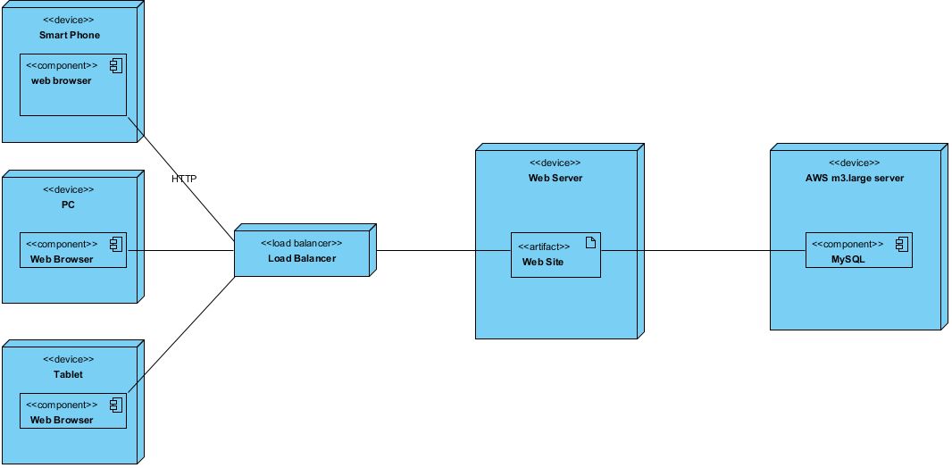

|  |  |
| --- | --- |
| Name | Value |
| Name | OpenFDA |
| Author | dlam |
| Create Date Time | Jun 24, 2015 5:12:49 PM |
| Last Modified | Jun 25, 2015 2:29:59 PM |
| Shape Presentation Option | 0 |

## Summary

|  |  |
| --- | --- |
| Name | Documentation |
| Image6.png Smart Phone |  |
| Image7.png web browser |  |
| Image6.png Web Server |  |
| Image6.png AWS m3.large server |  |
| Image6.png PC |  |
| Image6.png Load Balancer |  |
| Image7.png Web Browser |  |
| Image8.png Web Site |  |
| Image7.png MySQL |  |
| Image6.png Tablet |  |
| Image7.png Web Browser |  |

## Details

### Image6.png Smart Phone

|  |  |
| --- | --- |
| Name | Value |
| Active | false |
| Business Key Mutable | true |
| Business Model | false |
| Visibility | public |
| Abstract | false |
| Leaf | false |
| Root | false |
| Stereotypes | device |
| Quality Score | Very Bad |
| Quality Reason | |  |  | | --- | --- | | Problem | Suggestion | | Model element at root | Add model element to a container | | Name does not contain glossary terms | Define name as term in glossary | | Model element without any relationship | Connect model element with relationship | |
| Project Management | |  |  | | --- | --- | | Name | Value | | Author | dlam | | Create Date Time | Jun 19, 2015 2:23:57 PM | | Last Modified | Jun 24, 2015 5:13:58 PM | |

#### Resident Components

|  |  |
| --- | --- |
| Name | Documentation |
| Image7.png web browser |  |

### Image7.png web browser

|  |  |
| --- | --- |
| Name | Value |
| Active | false |
| Business Key Mutable | true |
| Business Model | false |
| Visibility | public |
| Abstract | false |
| Leaf | false |
| Root | false |
| Quality Score | Fair |
| Quality Reason | |  |  | | --- | --- | | Problem | Suggestion | | Name does not contain glossary terms | Define name as term in glossary | |
| Indirectly Instantiated | true |
| Project Management | |  |  | | --- | --- | | Name | Value | | Author | dlam | | Create Date Time | Jun 19, 2015 2:24:47 PM | | Last Modified | Jun 24, 2015 5:13:58 PM | |

#### Relationships

|  |  |
| --- | --- |
| HTTP : Association | |
| To | |  |  | | --- | --- | | Name | Value | | End Model Element | Image6.png Load Balancer | | Provide Property Getter Method | false | | Provide Property Setter Method | false | | Multiplicity | Unspecified | | Visibility | Unspecified | | Aggregation Kind | None | | Navigable | Navigable | | Derived | false | | Derived Union | false | | Read Only | false | | Static | false | | Leaf | false | | Type | Image6.png Load Balancer | | Project Management | |  |  | | --- | --- | | Name | Value | | Author | dlam | | Create Date Time | Jun 19, 2015 3:20:12 PM | | |
| Abstract | false |
| Leaf | false |
| Visibility | Unspecified |
| Quality Score | Fair |
| Quality Reason | |  |  | | --- | --- | | Problem | Suggestion | | Name does not contain glossary terms | Define name as term in glossary | |
| Derived | false |
| Project Management | |  |  | | --- | --- | | Name | Value | | Author | dlam | | Create Date Time | Jun 19, 2015 3:20:12 PM | | Last Modified | Jun 24, 2015 5:13:58 PM | |

### Image6.png Web Server

|  |  |
| --- | --- |
| Name | Value |
| Active | false |
| Business Key Mutable | true |
| Business Model | false |
| Visibility | public |
| Abstract | false |
| Leaf | false |
| Root | false |
| Stereotypes | device |
| Quality Score | Very Bad |
| Quality Reason | |  |  | | --- | --- | | Problem | Suggestion | | Model element at root | Add model element to a container | | Name does not contain glossary terms | Define name as term in glossary | | Model element without any relationship | Connect model element with relationship | |
| Project Management | |  |  | | --- | --- | | Name | Value | | Author | dlam | | Create Date Time | Jun 19, 2015 3:33:24 PM | | Last Modified | Jun 24, 2015 5:13:58 PM | |

### Image6.png AWS m3.large server

|  |  |
| --- | --- |
| Name | Value |
| Active | false |
| Business Key Mutable | true |
| Business Model | false |
| Visibility | public |
| Abstract | false |
| Leaf | false |
| Root | false |
| Stereotypes | device |
| Quality Score | Very Bad |
| Quality Reason | |  |  | | --- | --- | | Problem | Suggestion | | Model element at root | Add model element to a container | | Name does not contain glossary terms | Define name as term in glossary | | Model element without any relationship | Connect model element with relationship | |
| Project Management | |  |  | | --- | --- | | Name | Value | | Author | dlam | | Create Date Time | Jun 19, 2015 3:34:59 PM | | Last Modified | Jun 24, 2015 5:13:58 PM | |

#### Resident Components

|  |  |
| --- | --- |
| Name | Documentation |
| Image7.png MySQL |  |

### Image6.png PC

|  |  |
| --- | --- |
| Name | Value |
| Active | false |
| Business Key Mutable | true |
| Business Model | false |
| Visibility | public |
| Abstract | false |
| Leaf | false |
| Root | false |
| Stereotypes | device |
| Quality Score | Very Bad |
| Quality Reason | |  |  | | --- | --- | | Problem | Suggestion | | Model element at root | Add model element to a container | | Name does not contain glossary terms | Define name as term in glossary | | Model element without any relationship | Connect model element with relationship | |
| Project Management | |  |  | | --- | --- | | Name | Value | | Author | dlam | | Create Date Time | Jun 19, 2015 4:04:51 PM | | Last Modified | Jun 24, 2015 5:13:58 PM | |

#### Resident Components

|  |  |
| --- | --- |
| Name | Documentation |
| Image7.png Web Browser |  |

### Image6.png Load Balancer

|  |  |
| --- | --- |
| Name | Value |
| Active | false |
| Business Key Mutable | true |
| Business Model | false |
| Visibility | public |
| Abstract | false |
| Leaf | false |
| Root | false |
| Stereotypes | load balancer |
| Quality Score | Fair |
| Quality Reason | |  |  | | --- | --- | | Problem | Suggestion | | Model element at root | Add model element to a container | | Name does not contain glossary terms | Define name as term in glossary | |
| Project Management | |  |  | | --- | --- | | Name | Value | | Author | dlam | | Create Date Time | Jun 19, 2015 3:18:11 PM | | Last Modified | Jun 24, 2015 5:13:58 PM | |

#### Relationships

|  |  |
| --- | --- |
| Unnamed Association | |
| To | |  |  | | --- | --- | | Name | Value | | End Model Element | Image8.png Web Site | | Provide Property Getter Method | false | | Provide Property Setter Method | false | | Multiplicity | Unspecified | | Visibility | Unspecified | | Aggregation Kind | None | | Navigable | Navigable | | Derived | false | | Derived Union | false | | Read Only | false | | Static | false | | Leaf | false | | Type | Image8.png Web Site | | Project Management | |  |  | | --- | --- | | Name | Value | | Author | dlam | | Create Date Time | Jun 19, 2015 3:59:31 PM | | |
| Abstract | false |
| Leaf | false |
| Visibility | Unspecified |
| Quality Score | Good |
| Derived | false |
| Project Management | |  |  | | --- | --- | | Name | Value | | Author | dlam | | Create Date Time | Jun 19, 2015 3:59:31 PM | | Last Modified | Jun 24, 2015 5:13:58 PM | |
| HTTP : Association | |
| From | |  |  | | --- | --- | | Name | Value | | End Model Element | Image7.png web browser | | Provide Property Getter Method | false | | Provide Property Setter Method | false | | Multiplicity | Unspecified | | Visibility | Unspecified | | Aggregation Kind | None | | Navigable | Navigable | | Derived | false | | Derived Union | false | | Read Only | false | | Static | false | | Leaf | false | | Type | Image7.png web browser | | Project Management | |  |  | | --- | --- | | Name | Value | | Author | dlam | | Create Date Time | Jun 19, 2015 3:20:12 PM | | |
| Abstract | false |
| Leaf | false |
| Visibility | Unspecified |
| Quality Score | Fair |
| Quality Reason | |  |  | | --- | --- | | Problem | Suggestion | | Name does not contain glossary terms | Define name as term in glossary | |
| Derived | false |
| Project Management | |  |  | | --- | --- | | Name | Value | | Author | dlam | | Create Date Time | Jun 19, 2015 3:20:12 PM | | Last Modified | Jun 24, 2015 5:13:58 PM | |

|  |  |
| --- | --- |
| Unnamed Association | |
| From | |  |  | | --- | --- | | Name | Value | | End Model Element | Image7.png Web Browser | | Provide Property Getter Method | false | | Provide Property Setter Method | false | | Multiplicity | Unspecified | | Visibility | Unspecified | | Aggregation Kind | None | | Navigable | Navigable | | Derived | false | | Derived Union | false | | Read Only | false | | Static | false | | Leaf | false | | Type | Image7.png Web Browser | | Project Management | |  |  | | --- | --- | | Name | Value | | Author | dlam | | Create Date Time | Jun 19, 2015 4:07:00 PM | | |
| Abstract | false |
| Leaf | false |
| Visibility | Unspecified |
| Quality Score | Good |
| Derived | false |
| Project Management | |  |  | | --- | --- | | Name | Value | | Author | dlam | | Create Date Time | Jun 19, 2015 4:07:00 PM | | Last Modified | Jun 24, 2015 5:13:58 PM | |

|  |  |
| --- | --- |
| Unnamed Association | |
| From | |  |  | | --- | --- | | Name | Value | | End Model Element | Image7.png Web Browser | | Provide Property Getter Method | false | | Provide Property Setter Method | false | | Multiplicity | Unspecified | | Visibility | Unspecified | | Aggregation Kind | None | | Navigable | Navigable | | Derived | false | | Derived Union | false | | Read Only | false | | Static | false | | Leaf | false | | Type | Image7.png Web Browser | | Project Management | |  |  | | --- | --- | | Name | Value | | Author | dlam | | Create Date Time | Jun 19, 2015 4:07:05 PM | | |
| Abstract | false |
| Leaf | false |
| Visibility | Unspecified |
| Quality Score | Good |
| Derived | false |
| Project Management | |  |  | | --- | --- | | Name | Value | | Author | dlam | | Create Date Time | Jun 19, 2015 4:07:05 PM | | Last Modified | Jun 24, 2015 5:13:58 PM | |

### Image7.png Web Browser

|  |  |
| --- | --- |
| Name | Value |
| Active | false |
| Business Key Mutable | true |
| Business Model | false |
| Visibility | public |
| Abstract | false |
| Leaf | false |
| Root | false |
| Quality Score | Fair |
| Quality Reason | |  |  | | --- | --- | | Problem | Suggestion | | Name does not contain glossary terms | Define name as term in glossary | |
| Indirectly Instantiated | true |
| Project Management | |  |  | | --- | --- | | Name | Value | | Author | dlam | | Create Date Time | Jun 19, 2015 4:06:26 PM | | Last Modified | Jun 24, 2015 5:13:58 PM | |

#### Relationships

|  |  |
| --- | --- |
| Unnamed Association | |
| To | |  |  | | --- | --- | | Name | Value | | End Model Element | Image6.png Load Balancer | | Provide Property Getter Method | false | | Provide Property Setter Method | false | | Multiplicity | Unspecified | | Visibility | Unspecified | | Aggregation Kind | None | | Navigable | Navigable | | Derived | false | | Derived Union | false | | Read Only | false | | Static | false | | Leaf | false | | Type | Image6.png Load Balancer | | Project Management | |  |  | | --- | --- | | Name | Value | | Author | dlam | | Create Date Time | Jun 19, 2015 4:07:00 PM | | |
| Abstract | false |
| Leaf | false |
| Visibility | Unspecified |
| Quality Score | Good |
| Derived | false |
| Project Management | |  |  | | --- | --- | | Name | Value | | Author | dlam | | Create Date Time | Jun 19, 2015 4:07:00 PM | | Last Modified | Jun 24, 2015 5:13:58 PM | |

### Image8.png Web Site

|  |  |
| --- | --- |
| Name | Value |
| Abstract | false |
| Leaf | false |
| Visibility | Unspecified |
| Quality Score | Fair |
| Quality Reason | |  |  | | --- | --- | | Problem | Suggestion | | Name does not contain glossary terms | Define name as term in glossary | |
| Project Management | |  |  | | --- | --- | | Name | Value | | Author | dlam | | Create Date Time | Jun 19, 2015 3:56:56 PM | | Last Modified | Jun 24, 2015 5:13:58 PM | |

#### Relationships

|  |  |
| --- | --- |
| Unnamed Association | |
| To | |  |  | | --- | --- | | Name | Value | | End Model Element | Image7.png MySQL | | Provide Property Getter Method | false | | Provide Property Setter Method | false | | Multiplicity | Unspecified | | Visibility | Unspecified | | Aggregation Kind | None | | Navigable | Navigable | | Derived | false | | Derived Union | false | | Read Only | false | | Static | false | | Leaf | false | | Type | Image7.png MySQL | | Project Management | |  |  | | --- | --- | | Name | Value | | Author | dlam | | Create Date Time | Jun 19, 2015 3:59:16 PM | | |
| Abstract | false |
| Leaf | false |
| Visibility | Unspecified |
| Quality Score | Good |
| Derived | false |
| Project Management | |  |  | | --- | --- | | Name | Value | | Author | dlam | | Create Date Time | Jun 19, 2015 3:59:16 PM | | Last Modified | Jun 24, 2015 5:13:58 PM | |
| Unnamed Association | |
| From | |  |  | | --- | --- | | Name | Value | | End Model Element | Image6.png Load Balancer | | Provide Property Getter Method | false | | Provide Property Setter Method | false | | Multiplicity | Unspecified | | Visibility | Unspecified | | Aggregation Kind | None | | Navigable | Navigable | | Derived | false | | Derived Union | false | | Read Only | false | | Static | false | | Leaf | false | | Type | Image6.png Load Balancer | | Project Management | |  |  | | --- | --- | | Name | Value | | Author | dlam | | Create Date Time | Jun 19, 2015 3:59:31 PM | | |
| Abstract | false |
| Leaf | false |
| Visibility | Unspecified |
| Quality Score | Good |
| Derived | false |
| Project Management | |  |  | | --- | --- | | Name | Value | | Author | dlam | | Create Date Time | Jun 19, 2015 3:59:31 PM | | Last Modified | Jun 24, 2015 5:13:58 PM | |

### Image7.png MySQL

|  |  |
| --- | --- |
| Name | Value |
| Active | false |
| Business Key Mutable | true |
| Business Model | false |
| Visibility | public |
| Abstract | false |
| Leaf | false |
| Root | false |
| Quality Score | Fair |
| Quality Reason | |  |  | | --- | --- | | Problem | Suggestion | | Name does not contain glossary terms | Define name as term in glossary | |
| Indirectly Instantiated | true |
| Project Management | |  |  | | --- | --- | | Name | Value | | Author | dlam | | Create Date Time | Jun 19, 2015 3:54:49 PM | | Last Modified | Jun 24, 2015 5:13:58 PM | |

#### Relationships

|  |  |
| --- | --- |
| Unnamed Association | |
| From | |  |  | | --- | --- | | Name | Value | | End Model Element | Image8.png Web Site | | Provide Property Getter Method | false | | Provide Property Setter Method | false | | Multiplicity | Unspecified | | Visibility | Unspecified | | Aggregation Kind | None | | Navigable | Navigable | | Derived | false | | Derived Union | false | | Read Only | false | | Static | false | | Leaf | false | | Type | Image8.png Web Site | | Project Management | |  |  | | --- | --- | | Name | Value | | Author | dlam | | Create Date Time | Jun 19, 2015 3:59:16 PM | | |
| Abstract | false |
| Leaf | false |
| Visibility | Unspecified |
| Quality Score | Good |
| Derived | false |
| Project Management | |  |  | | --- | --- | | Name | Value | | Author | dlam | | Create Date Time | Jun 19, 2015 3:59:16 PM | | Last Modified | Jun 24, 2015 5:13:58 PM | |

### Image6.png Tablet

|  |  |
| --- | --- |
| Name | Value |
| Active | false |
| Business Key Mutable | true |
| Business Model | false |
| Visibility | public |
| Abstract | false |
| Leaf | false |
| Root | false |
| Stereotypes | device |
| Quality Score | Very Bad |
| Quality Reason | |  |  | | --- | --- | | Problem | Suggestion | | Model element at root | Add model element to a container | | Name does not contain glossary terms | Define name as term in glossary | | Model element without any relationship | Connect model element with relationship | |
| Project Management | |  |  | | --- | --- | | Name | Value | | Author | dlam | | Create Date Time | Jun 19, 2015 4:05:47 PM | | Last Modified | Jun 24, 2015 5:13:58 PM | |

#### Resident Components

|  |  |
| --- | --- |
| Name | Documentation |
| Image7.png Web Browser |  |

### Image7.png Web Browser

|  |  |
| --- | --- |
| Name | Value |
| Active | false |
| Business Key Mutable | true |
| Business Model | false |
| Visibility | public |
| Abstract | false |
| Leaf | false |
| Root | false |
| Quality Score | Fair |
| Quality Reason | |  |  | | --- | --- | | Problem | Suggestion | | Name does not contain glossary terms | Define name as term in glossary | |
| Indirectly Instantiated | true |
| Project Management | |  |  | | --- | --- | | Name | Value | | Author | dlam | | Create Date Time | Jun 19, 2015 4:06:46 PM | | Last Modified | Jun 24, 2015 5:13:58 PM | |

#### Relationships

|  |  |
| --- | --- |
| Unnamed Association | |
| To | |  |  | | --- | --- | | Name | Value | | End Model Element | Image6.png Load Balancer | | Provide Property Getter Method | false | | Provide Property Setter Method | false | | Multiplicity | Unspecified | | Visibility | Unspecified | | Aggregation Kind | None | | Navigable | Navigable | | Derived | false | | Derived Union | false | | Read Only | false | | Static | false | | Leaf | false | | Type | Image6.png Load Balancer | | Project Management | |  |  | | --- | --- | | Name | Value | | Author | dlam | | Create Date Time | Jun 19, 2015 4:07:05 PM | | |
| Abstract | false |
| Leaf | false |
| Visibility | Unspecified |
| Quality Score | Good |
| Derived | false |
| Project Management | |  |  | | --- | --- | | Name | Value | | Author | dlam | | Create Date Time | Jun 19, 2015 4:07:05 PM | | Last Modified | Jun 24, 2015 5:13:58 PM | |

Package Diagram

# com.wasoftware.openfda

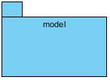

|  |  |
| --- | --- |
| Name | Value |
| Name | com.wasoftware.openfda |
| Author | dlam |
| Create Date Time | Jun 24, 2015 3:25:03 PM |
| Last Modified | Jul 6, 2015 10:17:38 AM |
| Shape Presentation Option | 0 |

## Summary

|  |  |
| --- | --- |
| Name | Documentation |
| Image10.png model |  |

## Details

### Image10.png model

|  |  |
| --- | --- |
| Name | Value |
| Abstract | false |
| Leaf | false |
| Root | false |
| Quality Score | Very Bad |
| Quality Reason | |  |  | | --- | --- | | Problem | Suggestion | | Name does not contain glossary terms | Define name as term in glossary | | Model element without any relationship | Connect model element with relationship | |
| Visibility | public |
| Project Management | |  |  | | --- | --- | | Name | Value | | Author | dlam | | Create Date Time | Jun 24, 2015 3:26:11 PM | | Last Modified | Jun 24, 2015 3:32:45 PM | |

Entity Relationship Diagram

# Entity Relationship Diagram1

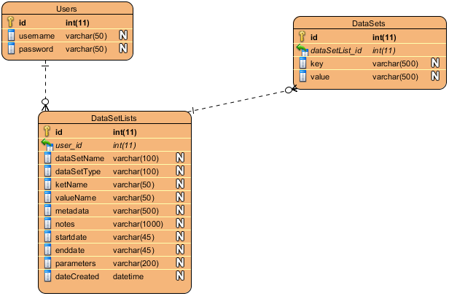

|  |  |
| --- | --- |
| Name | Value |
| Name | Entity Relationship Diagram1 |
| Author | dlam |
| Create Date Time | Jun 24, 2015 3:32:50 PM |
| Last Modified | Jul 6, 2015 10:17:38 AM |
| Transit To | Image12.png Class Diagram |
| Shape Presentation Option | 0 |
| Data Model | Physical |

## Summary

|  |  |
| --- | --- |
| Name | Documentation |
| Image4.png Users |  |
| Image4.png DataSets |  |
| Image4.png DataSetLists |  |

## Details

### Image4.png Users

|  |  |
| --- | --- |
| Name | Value |
| Data Model | Physical |
| Mapped Class | Image2.png Users |
| Quality Score | Fair |
| Quality Reason | |  |  | | --- | --- | | Problem | Suggestion | | Model element at root | Add model element to a container | | Name does not contain glossary terms | Define name as term in glossary | |
| Records | N/A |
| Project Management | |  |  | | --- | --- | | Name | Value | | Author | dlam | | Create Date Time | Jun 24, 2015 3:33:05 PM | | Last Modified | Jun 24, 2015 3:54:22 PM | |

#### Columns Summary

|  |  |  |  |  |
| --- | --- | --- | --- | --- |
| Name | DataType | Constraints | Nullable | Documentation |
| id | int(11) | PK | No |  |
| username | varchar(50) |  | Yes |  |
| password | varchar(50) |  | Yes |  |

#### Columns

|  |  |
| --- | --- |
| id | |
| Project Management | |  |  | | --- | --- | | Name | Value | |

|  |  |
| --- | --- |
| username | |
| Project Management | |  |  | | --- | --- | | Name | Value | |

|  |  |
| --- | --- |
| password | |
| Project Management | |  |  | | --- | --- | | Name | Value | |

#### Relationships

|  |  |
| --- | --- |
| Unnamed Relationship | |
| To | Image4.png DataSetLists |
| Quality Score | Good |
| Identifying | false |
| Subtype | false |
| To Multiplicity | 0..* |
| From Multiplicity | 1 |
| Sync To Association | Yes |
| Data Model | Physical |
| Project Management | |  |  | | --- | --- | | Name | Value | | Author | dlam | | Create Date Time | Jun 24, 2015 3:36:17 PM | | Last Modified | Jun 24, 2015 3:54:22 PM | |

### Image4.png DataSets

|  |  |
| --- | --- |
| Name | Value |
| Data Model | Physical |
| Mapped Class | Image2.png DataSets |
| Quality Score | Fair |
| Quality Reason | |  |  | | --- | --- | | Problem | Suggestion | | Model element at root | Add model element to a container | | Name does not contain glossary terms | Define name as term in glossary | |
| Records | N/A |
| Project Management | |  |  | | --- | --- | | Name | Value | | Author | dlam | | Create Date Time | Jun 24, 2015 3:35:25 PM | | Last Modified | Jun 24, 2015 3:54:22 PM | |

#### Columns Summary

|  |  |  |  |  |
| --- | --- | --- | --- | --- |
| Name | DataType | Constraints | Nullable | Documentation |
| id | int(11) | PK | No |  |
| dataSetList_id | int(11) | FK (DataSetLists.id) | No |  |
| key | varchar(500) |  | Yes |  |
| value | varchar(500) |  | Yes |  |

#### Columns

|  |  |
| --- | --- |
| id | |
| Project Management | |  |  | | --- | --- | | Name | Value | |

|  |  |
| --- | --- |
| dataSetList_id | |
| Project Management | |  |  | | --- | --- | | Name | Value | |

|  |  |
| --- | --- |
| key | |
| Project Management | |  |  | | --- | --- | | Name | Value | |

|  |  |
| --- | --- |
| value | |
| Project Management | |  |  | | --- | --- | | Name | Value | |

#### Relationships

|  |  |
| --- | --- |
| Unnamed Relationship | |
| From | Image4.png DataSetLists |
| Quality Score | Good |
| Identifying | false |
| Subtype | false |
| To Multiplicity | 0..* |
| From Multiplicity | 1 |
| Sync To Association | Yes |
| Data Model | Physical |
| Project Management | |  |  | | --- | --- | | Name | Value | | Author | dlam | | Create Date Time | Jun 24, 2015 3:36:26 PM | | Last Modified | Jun 24, 2015 3:54:22 PM | |

### Image4.png DataSetLists

|  |  |
| --- | --- |
| Name | Value |
| Data Model | Physical |
| Mapped Class | Image2.png DataSetLists |
| Quality Score | Fair |
| Quality Reason | |  |  | | --- | --- | | Problem | Suggestion | | Model element at root | Add model element to a container | | Name does not contain glossary terms | Define name as term in glossary | |
| Records | N/A |
| Project Management | |  |  | | --- | --- | | Name | Value | | Author | dlam | | Create Date Time | Jun 24, 2015 3:33:55 PM | | Last Modified | Jul 6, 2015 10:17:38 AM | |

#### Columns Summary

|  |  |  |  |  |
| --- | --- | --- | --- | --- |
| Name | DataType | Constraints | Nullable | Documentation |
| id | int(11) | PK | No |  |
| user_id | int(11) | FK (Users.id) | No |  |
| dataSetName | varchar(100) |  | Yes |  |
| dataSetType | varchar(100) |  | Yes |  |
| ketName | varchar(50) |  | Yes |  |
| valueName | varchar(50) |  | Yes |  |
| metadata | varchar(500) |  | Yes |  |
| notes | varchar(1000) |  | Yes |  |
| startdate | varchar(45) |  | Yes |  |
| enddate | varchar(45) |  | Yes |  |
| parameters | varchar(200) |  | Yes |  |
| dateCreated | datetime |  | Yes |  |

#### Columns

|  |  |
| --- | --- |
| id | |
| Project Management | |  |  | | --- | --- | | Name | Value | |

|  |  |
| --- | --- |
| user_id | |
| Project Management | |  |  | | --- | --- | | Name | Value | |

|  |  |
| --- | --- |
| dataSetName | |
| Project Management | |  |  | | --- | --- | | Name | Value | |

|  |  |
| --- | --- |
| dataSetType | |
| Project Management | |  |  | | --- | --- | | Name | Value | |

|  |  |
| --- | --- |
| ketName | |
| Project Management | |  |  | | --- | --- | | Name | Value | |

|  |  |
| --- | --- |
| valueName | |
| Project Management | |  |  | | --- | --- | | Name | Value | |

|  |  |
| --- | --- |
| metadata | |
| Project Management | |  |  | | --- | --- | | Name | Value | |

|  |  |
| --- | --- |
| notes | |
| Project Management | |  |  | | --- | --- | | Name | Value | |

|  |  |
| --- | --- |
| startdate | |
| Project Management | |  |  | | --- | --- | | Name | Value | |

|  |  |
| --- | --- |
| enddate | |
| Project Management | |  |  | | --- | --- | | Name | Value | |

|  |  |
| --- | --- |
| parameters | |
| Project Management | |  |  | | --- | --- | | Name | Value | |

|  |  |
| --- | --- |
| dateCreated | |
| Project Management | |  |  | | --- | --- | | Name | Value | |

#### Relationships

|  |  |
| --- | --- |
| Unnamed Relationship | |
| To | Image4.png DataSets |
| Quality Score | Good |
| Identifying | false |
| Subtype | false |
| To Multiplicity | 0..* |
| From Multiplicity | 1 |
| Sync To Association | Yes |
| Data Model | Physical |
| Project Management | |  |  | | --- | --- | | Name | Value | | Author | dlam | | Create Date Time | Jun 24, 2015 3:36:26 PM | | Last Modified | Jun 24, 2015 3:54:22 PM | |
| Unnamed Relationship | |
| From | Image4.png Users |
| Quality Score | Good |
| Identifying | false |
| Subtype | false |
| To Multiplicity | 0..* |
| From Multiplicity | 1 |
| Sync To Association | Yes |
| Data Model | Physical |
| Project Management | |  |  | | --- | --- | | Name | Value | | Author | dlam | | Create Date Time | Jun 24, 2015 3:36:17 PM | | Last Modified | Jun 24, 2015 3:54:22 PM | |

Web Wireframe

# Drugs Adverse Events

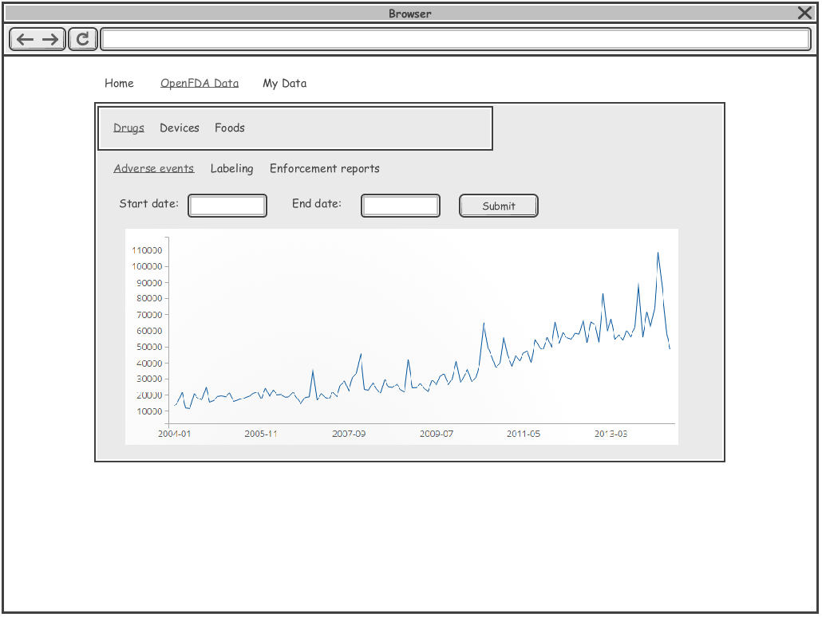

Initial

|  |  |
| --- | --- |
| Name | Value |
| Name | Drugs Adverse Events |
| Author | dlam |
| Create Date Time | Jun 25, 2015 12:01:50 PM |
| Last Modified | Jul 6, 2015 10:17:38 AM |
| Shape Presentation Option | 0 |

Web Wireframe

# Login

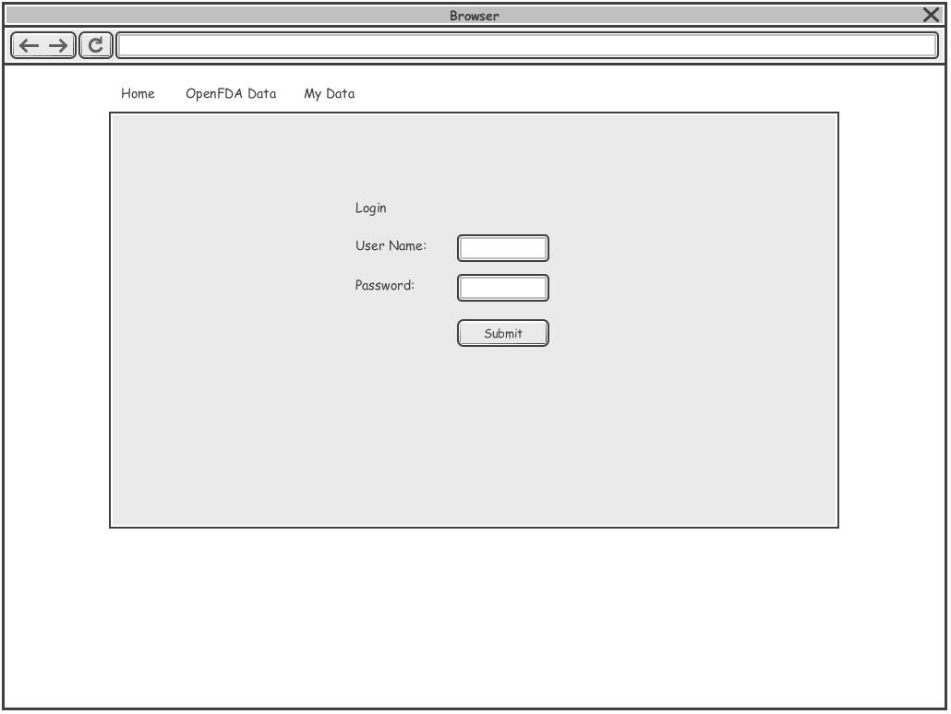

Initial

|  |  |
| --- | --- |
| Name | Value |
| Name | Login |
| Author | dlam |
| Create Date Time | Jun 25, 2015 12:01:02 PM |
| Last Modified | Jun 25, 2015 2:29:59 PM |
| Shape Presentation Option | 0 |

Web Wireframe

# Master

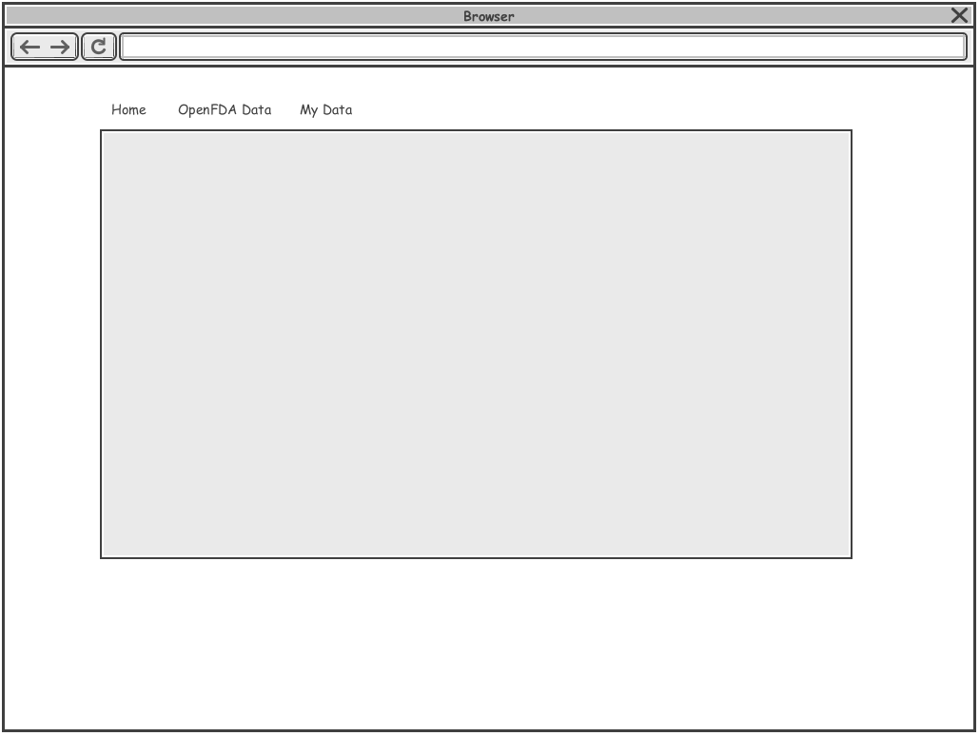

Initial

|  |  |
| --- | --- |
| Name | Value |
| Name | Master |
| Author | dlam |
| Create Date Time | Jun 25, 2015 11:59:02 AM |
| Last Modified | Jun 25, 2015 2:29:59 PM |
| Shape Presentation Option | 0 |